* **K-Nearest Neighbour** is one of the simplest Machine Learning algorithms based on Supervised Learning technique.
* K-NN algorithm assumes the similarity between the new case/data and available cases and put the new case into the category that is most similar to the available categories.
* K-NN algorithm stores all the available data and classifies a new data point based on the similarity. This means when new data appears then it can be easily classified into a well suite category by using K- NN algorithm.
* K-NN algorithm can be used for Regression as well as for Classification but mostly it is used for the Classification problems.

Advantages of KNN Algorithm:

* It is simple to implement.
* It is robust to the noisy training data
* It can be more effective if the training data is large

Disadvantages of KNN Algorithm:

* Always needs to determine the value of K which may be complex some time.
* The computation cost is high because of calculating the distance between the data points for all the training samples.

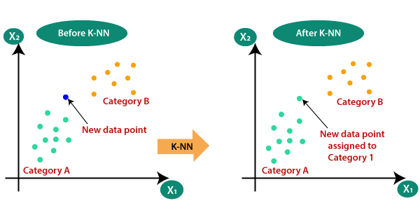

**Support Vector Machine** or SVM is one of the most popular Supervised Learning algorithms, which is used for Classification as well as Regression problems. However, primarily, it is used for Classification problems in Machine Learning.

The goal of the SVM algorithm is to create the best line or decision boundary that can segregate n-dimensional space into classes so that we can easily put the new data point in the correct category in the future. This best decision boundary is called a hyperplane.

**SVM can be of two types:**

* **Linear SVM:** Linear SVM is used for linearly separable data, which means if a dataset can be classified into two classes by using a single straight line, then such data is termed as linearly separable data, and classifier is used called as Linear SVM classifier.
* **Non-linear SVM:** Non-Linear SVM is used for non-linearly separated data, which means if a dataset cannot be classified by using a straight line, then such data is termed as non-linear data and classifier used is called as Non-linear SVM classifier.